**Software required** :Eclipse and JDK

**Driver** : Edge driver

**Jar files required** : Apache POI Jar files and selenium jar files

**Script** : JavaScript

**Task 13: Encode and Decode the String:**

**Step 1: Creating files:**

Open the eclipse and create a java project 🡪 Create Package under the project file 🡪 Create class file under the package. This step is common for all projects.

Importing the selenium jar files. Go to project file 🡪 right click on project file 🡪 select build path 🡪 library’s 🡪select class path 🡪 add external jars 🡪 select all selenium jar files 🡪 apply and close.

**Step 2: Launching the web driver:**

Download the preferred web driver and set the driver to launch the browser during execution of script. mention the driver location in string format in to the script to invoke web driver.

**Step 3: write the script for encode and decode string:**

Get one demo website to perform Encoding and decoding the String by using get method. convert the string to binary value. refer below code to perform encode and decode.

**package** UsingOfWebElements;

**import** org.apache.commons.codec.binary.Base64;

**public** **class** EncodeAndDecodeString {

**public** **static** **void** main(String[] args) {

String str="Keerthiraja@7";

**byte**[] encodedString=Base64.*encodeBase64*(str.getBytes());

System.*out*.println("Encoded String : "+ **new** String(encodedString));

**byte**[] decodedString=Base64.*decodeBase64*(encodedString);

System.*out*.println("Decoded String : "+ **new** String(decodedString));

}

}

**Output:**

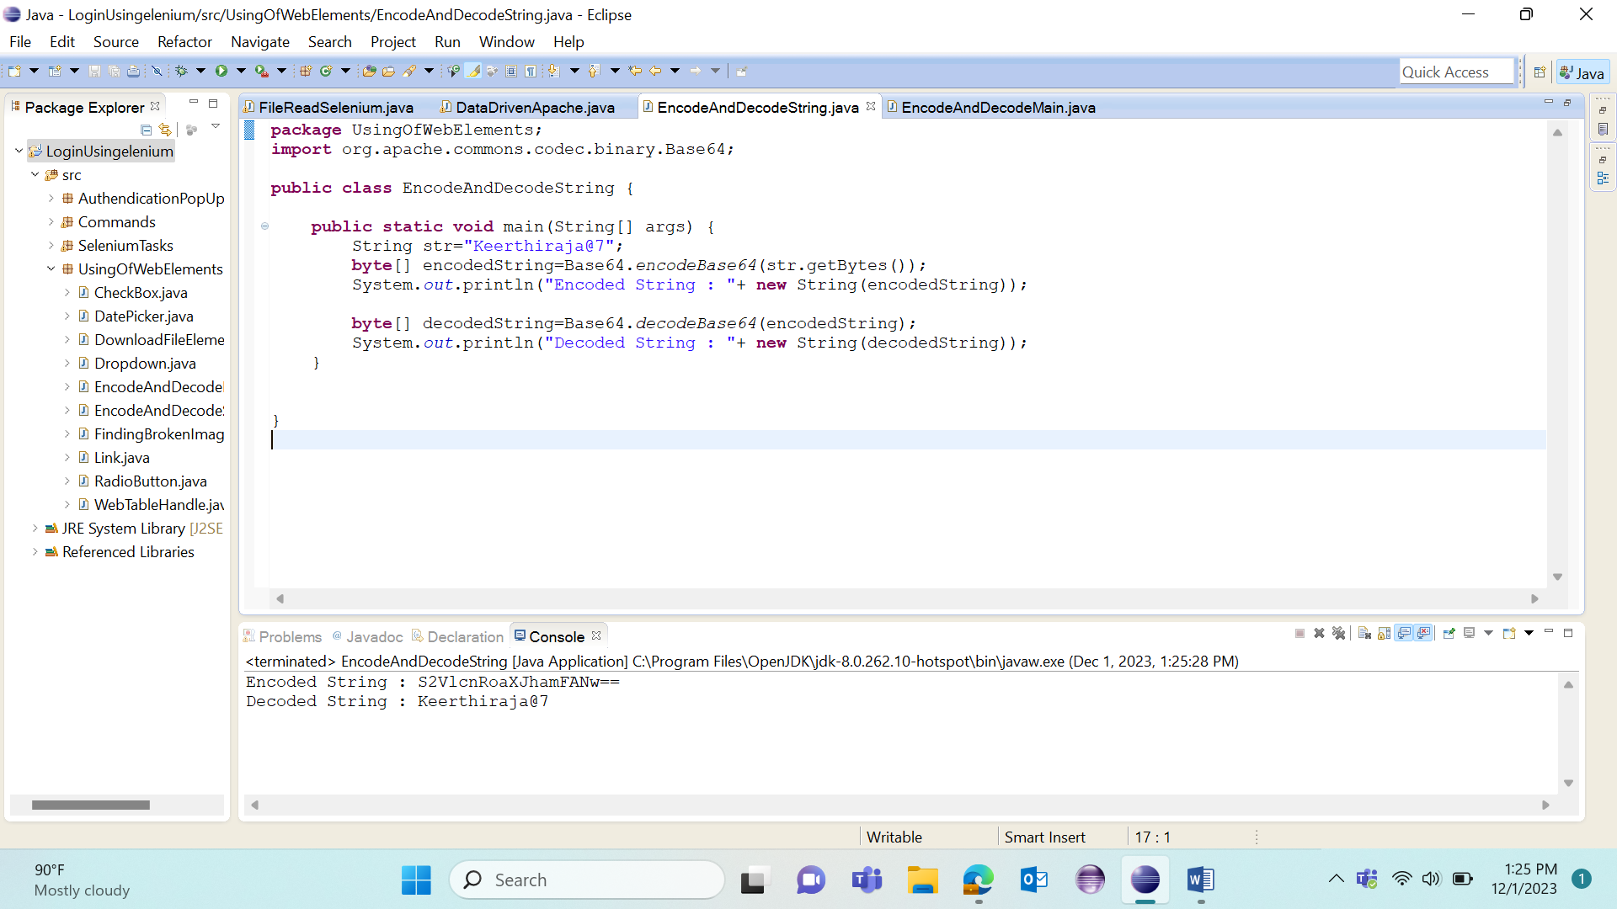

Write the code for web element to pass the encoded string in to the password text box.

**package** UsingOfWebElements;

**import** org.apache.commons.codec.binary.Base64;

**import** org.openqa.selenium.By;

**import** org.openqa.selenium.WebDriver;

**import** org.openqa.selenium.edge.EdgeDriver;

**public** **class** EncodeAndDecodeMain {

**public** **static** **void** main(String[] args) {

System.*setProperty*("webdriver.edge.driver", "C:\\Users\\keerthiraja.sp\\Downloads\\edgedriver_win64\\msedgedriver.exe");

WebDriver driver =**new** EdgeDriver();

driver.manage().window().maximize();

driver.get("https://www.nopcommerce.com/en/login");

driver.findElement(By.*className*("username")).sendKeys("keerthiraja1999@gmail.com");

driver.findElement(By.*xpath*("/html/body/div[7]/section/div/div/div/div/div/div[2]/div[1]/div[2]/form/div[2]/div[2]/input")).sendKeys(*decodeString*("S2VlcnRoaXJhamFANw=="));

//driver.findElement(By.xpath("/html/body/div[7]/section/div/div/div/div/div/div[2]/div[1]/div[2]/form/div[2]/div[4]/input")).click();

}

**static** String decodeString(String password){

**byte**[] decodedString=Base64.*decodeBase64*(password);

**return** (**new** String(decodedString));

}}

**Output:**

